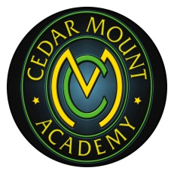
Cedar Mount Academy
(Part f the Bright Futures Educational Trust)

HEAD OF ART & TECHNOLOGY

Salary: MPS PLUS TLR2B
Closing Date: Friday 5TH May 2017 (12 noon)
Interview date: Wednesday 10th May 2017
Start date: September 2017

The Academy is seeking to appoint a Head of Art who will inspire our students with the Academy’s vision and values; that will have a passion for Art and be committed to raising standards. You will have a proven record of success in the classroom where you have made a positive difference through teaching.

You will be;
- an outstanding, experienced teacher with a strong commitment to the highest standards for teaching and learning;
- be able to inspire and motivate students to achieve excellent results;
- be passionate about giving all children an equal chance for a successful life through education

Why Join the Cedar Mount Academy?

This is an exciting opportunity to join a team who want to enhance, develop and inspire the young people at Cedar Mount Academy. You will become a part of a supportive, hard-working and talented group of teachers who aim to provide the very best learning experiences for all.

In our most recent Ofsted visit, inspectors commented that a ‘high priority is given to ensuring that all pupils receive high quality teaching’ whilst pupils explained that ‘teachers really want us to succeed’.

The Bright Futures Educational Trust is committed to safeguarding and promoting the welfare of children and young people and expects all staff and volunteers to share this commitment. Any successful applicant will be required to undertake an Enhanced Disclosure by the Criminal Records Bureau. The post is exempt from the Rehabilitation of Offenders Act 1974

If you want to be a part of our team and join us on our exciting journey, then we look forward to reading your application. Application forms must be returned to Chris Barber, H.R. no later than 12 noon on the closing date stated above. Details for interview will be sent as soon after the closing date as possible. Only shortlisted candidates will be contacted.

For further information on the school please also visit the schools website http://www.cedarmount.manchester.sch.uk

