Home School Agreement for ____________________

I/we shall:
- Ensure that my son/daughter attends school regularly, on time and properly equipped, understanding that attendance and punctuality are key elements to progress and achievement.
- Inform school immediately over any absence/illness
- Make the school aware of any concerns of problems that might affect my son/daughter’s work or behaviour by contacting the Form Tutor, Progress Leader or Assistant Progress Leader.
- Support the School’s policies for Behaviour learning guidelines – Hard Work, Respect and Aspiration.
- Support the school’s Anti-Bullying policy.
- Support my son/daughter in homework and other opportunities for home learning.
- Consistently attend parent/carers’ evenings and discussions about my son/daughter’s progress as this contact and communication is key to our partnership with school.
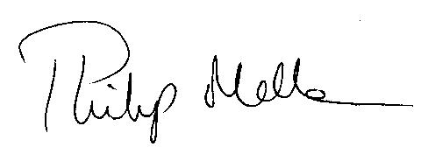
Principal’s Signature

Parent/Carer
Signature

Cedar Mount Academy will work to:
- Care for your son/daughter’s safety and happiness.
- Ensure that your son/daughter achieve their full potential as a valued member of the school community.
- Provide a balanced curriculum and meet the individual needs of your son/daughter.
- Achieve high standards of work and behaviour through building good relationships and developing a sense of Hard Work, Respect and Aspiration.
- Keep you informed about general school matters and about your son/daughter’s progress in particular.
- Be open and welcoming at all times and offer opportunities for you to become involved in the daily life of school.
I Shall:
- Attend school and be on time, understanding this is my responsibility.
- Bring all the equipment I need every day, understanding this is my responsibility.
- Wear the school uniform correctly and with pride and be tidy in my appearance.
- Support the school’s Anti-Bullying policy and be respectful to all staff and students.
- Do all my class work and homework as well as I can, understanding this is my responsibility to complete it.
- Be polite and helpful to others.
- Keep the school free from litter and graffiti.
Principal’s Signature

Student Signature

