**Pupil Premium Grant Plan 2016-17 evaluation**

|  |  |
| --- | --- |
| **Number of pupils and pupil premium grant (PPG) received 2016** | |
| **Total number of pupils on roll (Jan 2017)** | **690** |
| **Total number of pupils eligible for PPG** | **356 (51.6%)** |
| **Amount of PPG received per pupil** | **£930** |
| **Total amount of PPG received 2016/2017** | **£331,110** |

Last year 51% of our students at Cedar Mount Academy were eligible for the Pupil Premium Grant which is higher than the national figure. Cedar Mount recognizes that each individual student has different needs, concerns and aspirations and we aim to ensure the best outcomes for everyone irrelevant of their background and disadvantages. For some students, this may be supporting their progress in reading, whilst for others it may be providing support for individual music lessons, or University visits. The Academy is committed to closing the attainment and achievement gap across a range of measures for our disadvantaged pupils particularly, and the funding will be used to support this aim. We recognize the attainment gap between our disadvantaged students and their peers exists. Please refer to the Pupil Premium action plan to see how the academy is strategically planning to remove the gap by 2018/19.

**Outcomes**

|  |  |  |  |
| --- | --- | --- | --- |
| **Data Set** | **Outcomes**  **2015/16** | **Outcomes 2016/ 2017** | |
| **9-5** | **9-4** |
| **Basics**  **(A*-C E&M)** | ALL 28.1%  PP 27.6%  Non-PP 30%  Internal Gap -2.4%  National Gap 42% | ALL 15.7%  PP 10.3%  Non-PP 23.4%  Internal Gap -13.1%  National Gap (All Students) 31.9% | ALL 30.4%  PP 22.1%  Non-PP 42.6%  Internal Gap -20.5%  National Gap (All Students) 41% |
| **Progress 8** | ALL -0.87  PP -1.13  Non-PP 0.05  Internal Gap– (PP Vs Non-PP) -1.18  National Gap -1.25 | ALL -0.82  PP -1.02  Non-PP -0.4  Internal Gap – (PP Vs Non-PP) 0.62  National Non PP data pending | |

**Nature of Support 2017/18:**

* Appointment of an Associate Assistant Vice Principal with the responsibility for Pupil Premium Students.
* Developing links with GM Higher to increase the number of students accessing FE and HE.
* Developing a peer mentoring programme across the academy to support with reading.
* Class reading intervention to take place in progress time.
* Outside the classroom learning programme to build confidence and develop resilience amongst PP students.
* Raising Attainment Panel meetings with a focus on disadvantaged students progress.
* Pupil Premium CPD cycle for all staff focussing on strategies to narrow the attainment gap.
* Develop a PP development group with PP champions who meet regularly with clear agendas on closing the gap.
* All KS4 PP high ability pupils to be placed on High Ability Pupil Initiative.
* Develop SIMS interventions module to track and monitor PP student participation to visits and trips.
* Progress Leaders and Assistant Progress Leaders review progress, attendance and behaviour weekly and identify students at risk of underachievement.
* An attendance panel established each half term for PP students with poor attendance.

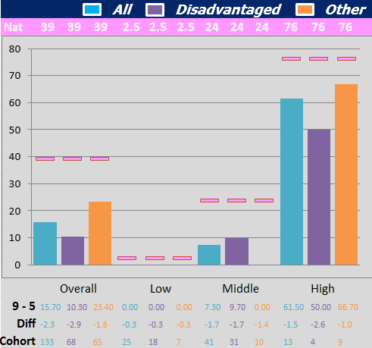**2017 % attained English & mathematics 9 – 5 2017 % attained English & mathematics 9 - 4**

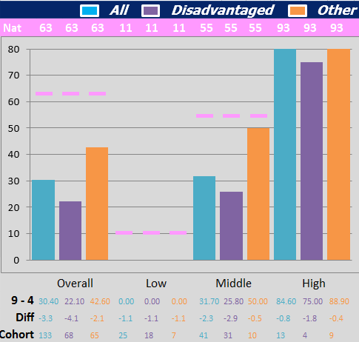

Please note national averages have been taken from the provisional data available from the DfE.

**Evaluation of PP spend 2016/17:**

|  |  |  |
| --- | --- | --- |
| **Strategy** | **Cost (£)** | **Impact / Evaluation** |
| Academic mentors used to run intervention with Year 11 students. This took the form of one to one intervention or small group intervention. These have been sighted as having a positive impact from the Education Endowment Fund. Maths, English and intervention support had 3 members of associate staff with a year 11 focus. | 97288 | Pupil Premium students made up in excess of 60% of the students involved with the intervention sessions which was above their representation in the cohort.  22% of Pupil Premium students achieved 9-4 English and maths basics compared to 42.6% for their non-Pupil Premium peers.  10.3% of Pupil Premium students achieved 9-5 English and maths basics compared to 23.4% for their non-Pupil Premium peers. |
| 50% of an AVP salary with specific focus on Pupil Premium. Pupils entitled to the Pupil Premium Grant are tracked extensively throughout their time at school. AVP held to account for the progress of Pupil Premium students in SIB meetings, so that we can monitor their progress in comparison to their peers. | 36082 | Progress 8 measures for the Pupil Premium cohort was -1.025 compared to -0.40 for non-Pupil Premium students.  Pupil Premium learners have had increased access to enrichment activities, including Saturday and holiday revision sessions. 40% of non-Pupil Premium attended fewer than 5 sessions with this figure being only 47% of Pupil Premium learners. March 2017 – Pupil Premium attendance for year 11 to revision sessions average 45.5%. |
| Weekly book scrutiny’s to take place. Lists of Pupil Premium student’s books were requested within each department. Disadvantaged Learners made progress because of the improvement in quality first Teaching and Learning (72% by end of year). | 0 | In English Language 9.6% of Pupil Premium students made expected or better progress compared to 7.7% for their non-Pupil Premium peers.  22.6% of Pupil Premium students had a positive Progress 8 measure compared to 42.3% of non-Pupil Premium students. |
| Tracking stickers to be produced and printed. All students were encouraged to keep track of their progress to demonstrate progress over time. | 500 | Progress stickers supported the Progress 8 measures for the Pupil Premium cohort to -1.025 compared to -0.40 for non-Pupil Premium students. |
| Small group tuition for identified students in English and maths. 50% of 2 additional English staff salary supported by the Pupil Premium Grant. These staff led small group tuition including the vocabulary enrichment programme. | 29785 | 39 students took part in the vocabulary enrichment programme. Pupil Premium students formed more than 60% of the cohort targeted.  The average vocabulary score (across Years 9, 10 and 11) increased from 4.7 to 10.  25 out of 39 students improved their vocabulary by a score of 3 or more.  14 students scored a maximum of 15 out or 15 as a result of the vocabulary enrichment programme. |
| Reading intervention, carried out in small groups by EAL TA’s (max 4:1 ratio) is essential in ensuring students can participate fully in mainstream classes, and make the most progress. Two members of associate staff with a specific focus on supporting and developing reading across the academy. | 2070 | Pupil Premium students made up in excess of 60% of the reading intervention classes which was above their representation in the cohort.  Table shows improvement in mean reading ages for **ALL** students for all year groups   |  |  | | --- | --- | |  | Actual Mean Increase in Reading Age May-Oct | | Mean Reading Age Y11 | 1yr 10mths | | Mean Reading Age Y10 | 1yr 10mths | | Mean Reading Age Y9 | 2yrs 1mth | | Mean Reading Age Y8 | 2yrs 1mth | | Mean Reading Age Y7 |  | |
| Strategy needed to track pupil behaviour by group, but specifically with a Pupil Premium focus. 60% of Assistant Progress Leaders time. Pupils entitled to the Pupil Premium Grant are tracked extensively throughout their time at school. Assistant Progress Leaders are held to account for the progress of Pupil Premium students in line management meetings, so that we can see how they doing in comparison to their peers. | 71233 | APL staff supported the reduction in the number of Pupil Premium students receiving fixed term exclusions:  December 2016 – 79% of exclusions are Pupil Premium learners - March 2017 – 66% of exclusions are Pupil Premium learners.   |  |  |  | | --- | --- | --- | | Time period | Number of Exclusions (by session) | Percentage of incidents attributed to PP students | | Half term 1 | 76 | 64% (49/76) | | Half term 2 | 102 | 79% (81/102) | | Half term 3 | 60 | 62% (37/60) | | Half term 4 | 50 | 62% (31/50) | | Half term 5 | 59 | 66% (39/59) |   Average attendance to the academy for Pupil Premium students was 91.57% compared to 95.98 for their non-Pupil Premium peers.  In year 11 average Attendance to the academy for Pupil Premium students was 92% compared to 95.18 for their non-Pupil Premium peers.  25.9% of Pupil Premium students were classified as persistently absent compared to 11.17% for their non-Pupil Premium peers.  On average Pupil Premium students had received 135 behaviour points per student compared to 58 for their non-Pupil Premium peers.  On average Pupil premium students had received 143 achievement points per student compared to 166 for their non-Pupil Premium peers. |
| Additional Progress Leaders TLR so that each year group has a teaching member of staff monitoring and supporting Pupil Premium. Pupils entitled to the Pupil Premium Grant are tracked extensively throughout their time at school. Progress Leaders are held to account for the progress of Pupil Premium students in line management meetings, so that we can see how they doing in comparison to their peers. | 18000 | Average attendance to key exams was significantly higher than for average school days.   |  |  |  |  |  | | --- | --- | --- | --- | --- | |  | **Pupils in group** | **Attendances during the exam period (15/5 – 15/6)** | **Attendance during the academic year (September to May)** | **Difference** | | Pupil Premium | 68 | 88.62 | 86.69 | +1.93% | | N Pupil Premium | 63 | 95.37 | 94.36 | +1.01% |   Progress 8 differences between PP and non-PP learners down the Academy.   |  |  | | --- | --- | | **Year Group** | **Average Progress 8** | | 10 PP | -1.29 | | 10 non-PP | -0.73 | | Difference | **-0.56** | | 9 PP | -0.4 | | 9 non-PP | -0.14 | | Difference | **-0.36** | | 8 PP | -0.42 | | 8 non-PP | -0.23 | | Difference | **-0.21** | | 7 PP | -3.05 | | 7 non-PP | -2.95 | | Difference | **-0.1** | |
| Improve the Alternative Provision in the Academy by employing an Alternative Provision manager at grade 6. 50% of salary supported by Pupil Premium Grant. Member of staff responsible for tracking, monitoring and supporting cohort of student studying at the alternative provision. | 16532 | The Alternative Provision cohort had in excess of 70% PP. Our vulnerable students contributed negatively (-2.998) towards progress 8. This compares to -0.575 for the non-vulnerable students. |
| Uniform | 140 | Stock of uniform purchased to ensure disadvantaged students had access to correct uniform if required. This supported the average improvement of attendance to the academy for Pupil Premium students to 91.57%. |
| Additional staffing to decrease class sizes. 2 x English staff were recruited to support with reducing the class sizes in English. 1 x staff member was recruited to reduce the class sizes in Science. | 4548 | Last year the number of students who secured 2xC+ in Science was 25 (26%), therefore there has been a slight improvement in this measure (30%).  In English Language 9.6% of Pupil Premium students made expected or better progress compared to 7.7% for their non-Pupil Premium peers.  75% of Upper ability Pupil Premium students achieved a 9-4 in English.  100% of Upper ability Pupil premium students achieved 9-4 in Maths. |
| Create links with families to identify individual needs through our parental support advisor. 50% of salary supported by Pupil Premium Grant. Early Help Officer appointed to support with offering early help intervention with families. | 14961 | When looking at the number of students under early help there was a significant number of Pupil Premium students being supported and referred. This was in excess of 70% of the cases dealt with.  Early Help Officer supported the improvement in average attendance to the academy for Pupil Premium students to 91.57%.  Early Help Officer supported the reduction in the number of Pupil Premium students receiving fixed term exclusions:  December 2016 – 79% of exclusions are Pupil Premium learners - March 2017 – 66% of exclusions are Pupil Premium learners. |
| Opportunities to visit universities to raise aspirations. Students from across KS4 were given various opportunities to visit many Higher Education and Further Education institutes from across the local area. | 0 | Pupil Premium students made up in excess 40% which was in line their representation in the cohort.  10 students applied to Connell College, a member within the Bright Futures Educational trust, which was a 100% improvement on the previous academic year. |
| Specialist equipment to support access arrangements for year 11 students in their GCSE examinations. | 1448 | Having specialist equipment for the GCSE exams supported the improvement in average Pupil Premium attendance to GCSE exams. Attendance to the exams was significantly higher than for average school days +1.93% for Pupil premium students. |
| City Year - 7 additional staff formed part of the City Year team. These supported with attendance, punctuality and behaviour across the academy. The City year team worked with 68 targeted students with 39% being Pupil Premium. The City year initiative was not as effective as was hoped although they did have positive impact on some individual Pupil Premium students’ attendance. The contract was not renewed. | 36000 | Average number of behaviour points for the whole Focus List decreased by 37%.  Average number of behaviour points for Year 7 Focus list decreased by 12%.  Average number of behaviour points for Year 8 Focus List decreased by 58%.  Average number of behaviour points for Year 9 Focus List decreased by 30%.  Average number of behaviour points for Year 11 Focus List decreased by 33%.  Average attendance for the whole Focus List decreased by 7%.  Average attendance for the Year 7 Focus List decreased by 5%.  Average attendance for the Year 8 Focus List decreased by 19%.  Average attendance for the Year 9 Focus List decreased by 1%.  Average attendance for the Year 11 Focus List decreased by 2%.  Average number of minutes late to lesson for the whole focus list decreased by 42% |
| Youth engagement work. After school activity with over 50% PP participation on a weekly basis. | 3333 | The youth engagement project supported the improvement of attendance to the academy for Pupil Premium students. Average Pupil Premium attendance to the academy was 91.57% compared to 95.98 for their non-Pupil Premium peers. |
| Stretch and challenge workshops targeting Pupil Premium students. | 1250 | 3% of the whole cohort achieved 7-9 in English and Maths  1 Pupil Premium student achieved 7-9 in English and Maths  50% of Upper ability Pupil Premium students achieved a 7-9 in English.  25% of Upper ability Pupil Premium students achieved 7-9 in Maths. |
| **Total PP Spend** | **333 170** |  |



**Historical Data**