19th July 2018

Dear Parents, Carers and Students,

I am writing to confirm to you that I will be moving on from Cedar Mount in the Autumn Term to take up the role of Director of Education at Leeds City Council. I will be sad to leave as I have thoroughly enjoyed my time at the school and working with you, the students and the staff here.

I am glad to see that Cedar Mount has improved a great deal in the last couple of years and that we are confident of a much improved set of exam results this Summer, as well as a continued progression towards a ‘good’ Ofsted grading in the next year or so.

Far more importantly, I know that students at our school are far safer and have much better opportunities in a whole range of areas, from sport to residential trips to university links and much more. The school will continue to get excellent support from Bright Futures Educational Trust and the other schools within that partnership and I am glad that they have been successful in appointing Mr Kal Hodgson as my successor. He will bring a wealth of experience and wisdom to the role and will work closely with our existing staff team to ensure that Cedar Mount continues on its upward journey.

I will be working closely with him over the coming months to ensure a smooth and successful handover. Thank you for all your encouragement and support during my time at Cedar Mount and I know that you will continue to offer that same support to the school in the future.

All the best
Kind regards,
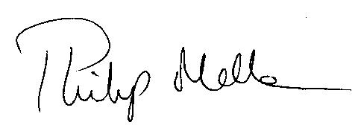
Phil Mellen
Principal

Message from Bright Futures Educational Trust

Dear Parents, Carers and Students,

You will know from Mr Mellen that he will be moving on from Cedar Mount in order to take up a senior role within Leeds City Council. I am sure you will join me in congratulating Mr Mellen on his appointment and in thanking him for his excellent work at Cedar Mount, at Rushbrook and at Stanley Grove. We will really miss him.

I am really pleased that we had lots of interest in the post of Principal at Cedar Mount from all over the country. We involved groups of staff and students in the appointment of the new principal and I am delighted that we have offered the post to Mr Kal Hodgson. Mr Hodgson has worked in a number of outstanding schools in the North West, and is therefore ideally placed to lead Cedar Mount on its exciting journey of improvement.

Mr Mellen will remain with us as Principal in the autumn so there will be a smooth handover and plenty of opportunities for us to celebrate with him and say a proper farewell.

Wishing you all the best for the summer break,

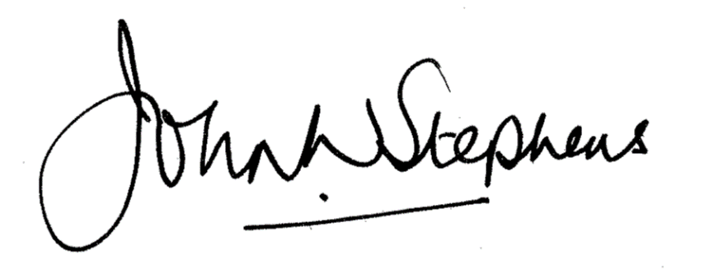

Dr John Wm Stephens, CBE
Chief Executive Officer, Bright Futures Educational Trust

